WHMCS is an all-in-one client management, billing & support solution for online businesses.

The Monitis addon for WHMCS provides integration with the Monitis platform including:

• Automation of monitor setup and management for hosting providers (Uptime: Ping, Server/Device: CPU, Memory, Drive)

• Automation of monitor setup and management for customers, based on Products / Product addons and Configurable Options (Uptime: HTTP, HTTPS, Ping)

• Direct access to monitoring data and statuses on the WHMCS admin panel and client area

The Monitis Addon requires WHMCS V5.1.2 or later.

**MONITIS ADDON SETUP**

1. Upload the Monitis_addon folder to the /modules/addons/ directory of your WHMCS installation
2. For setting up the client’s area:
   1. Upload monitis_monitors.php and monitis_networkstatus.php into the WHMCS root folder.
   2. Upload monitis_monitors.tpl and monitis_networkstatus.tpl into the WHMCS *templates* folder (you can find the folder name in Setup> General Settings> Template).
   3. Add a new tab in the main navigation template for the clients area (header.tpl ) and establish two links to the page monitis_monitors.php and monitis_networkstatus.php.
3. Navigate to Setup > Addon Modules in your WHMCS Admin Area to activate and configure the addon module. Here you should provide a User name for WHMCS API access. This User role can have no rights. Access Control checkboxes allow you to define which role groups you want to allow to access the WHMCS addons. Please note that only **Full Administrator** role groups can have access to the Monitis Addon.
4. Once you're done configuring the access rights, click **Save** to complete the process.

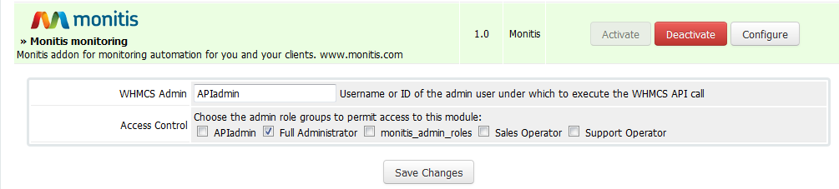

**MONITIS ADDON CONFIGURATION**

The initial configuration of the Monitis addon is accessed from the addon itself. In WHMSC Admin area navigate to Addons>Monitis monitoring.

Monitis Addon has three menu areas: Admin, Clients and Reports. When entering Monitis addon for the first time you will be navigated to Admin>Monitis Account Credentials tab where you have to enter the Monitis API key and Secret Key. For getting API key and Secret key go to the Monitis Dashboard and then to Account/API key.

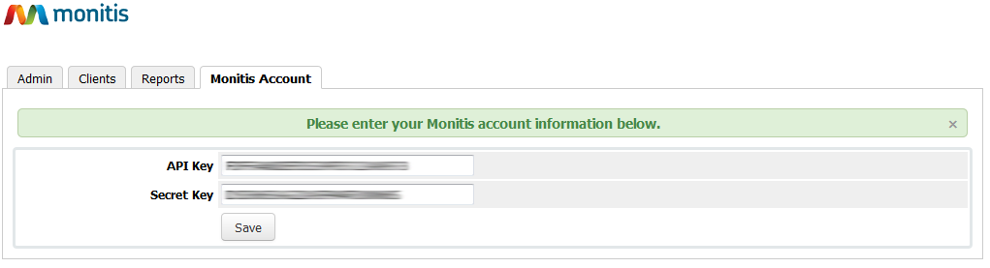

On Admin>Monitor Configuration tab please review the default monitor settings for your existing and newly provisioned servers.

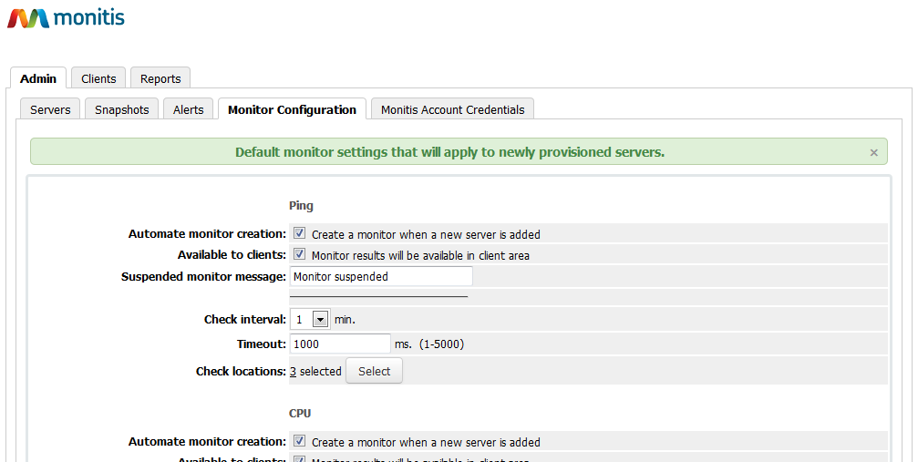

**Automate monitor creation** means that at the adding of a new server a corresponding monitor for it will be created automatically.

**Available to customer** means that this monitor will be shared with the clients having products on the given servers in WHMC client area under Monitoring>Network status tab.

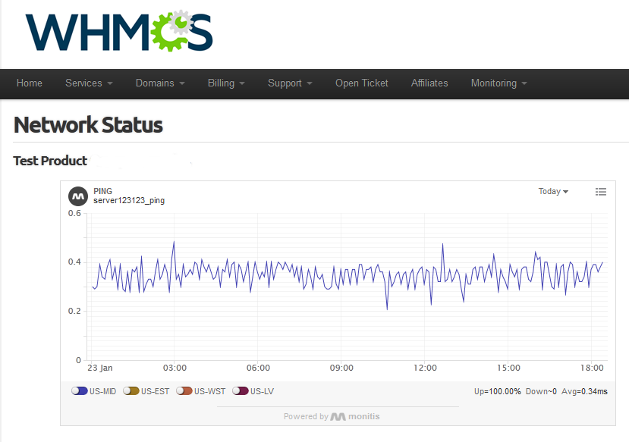

Now set the properties in accordance with your Monitis account plan.

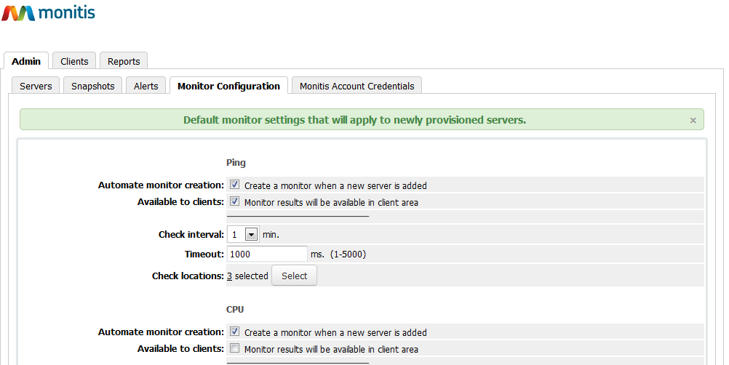

**MONITORING AUTOMATION FOR HOSTING PROVIDER**

After initial configuration is done you will be offered to create monitors for all the existing servers.

On Admin>Servers tab you will see all your servers and created monitors.

Note that for creating Ping monitors server’s an IP address is used. For Server/Device monitoring the prerequisite is that the Monitis agent installed on the server. The agent name should be the same as the server’s Host name.

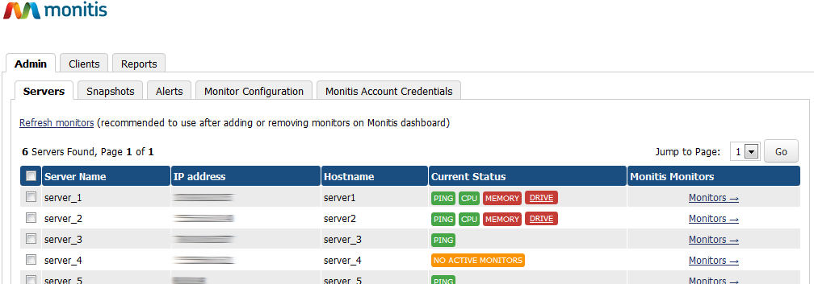

All the servers monitors will be created under your Monitis account and will be available on your Monitis dashboard as well.

It is not recommended to make changes or add monitors for servers directly from the Monitis dashboard. Nevertheless, you can use Refresh monitors link to update information on WHMCS when such changes are done.

Press the Monitors link to see detailed monitoring results and manage monitors for each server.

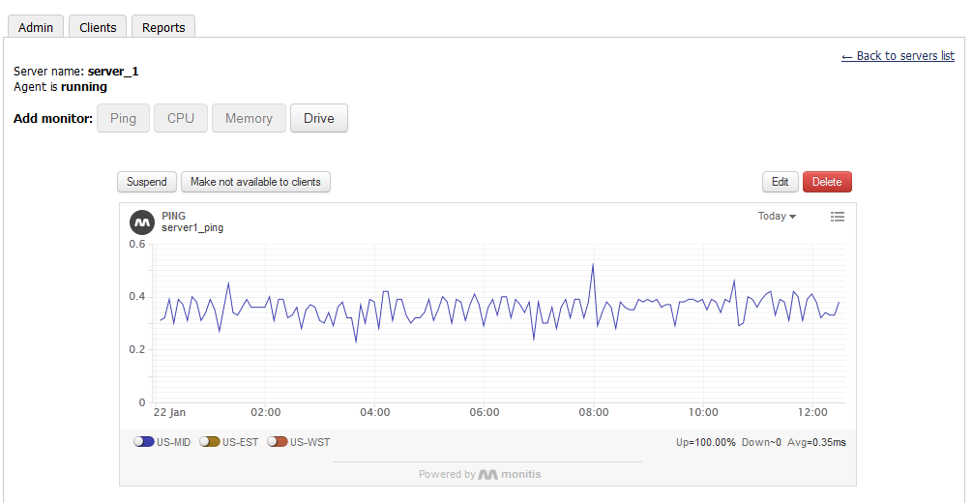

Snapshot view is available on the Admin>Snapshots tab.

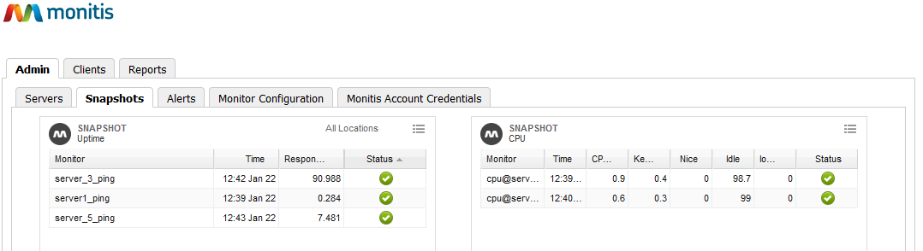

For setting up alerts and notification rules go to Admin>Alerts.

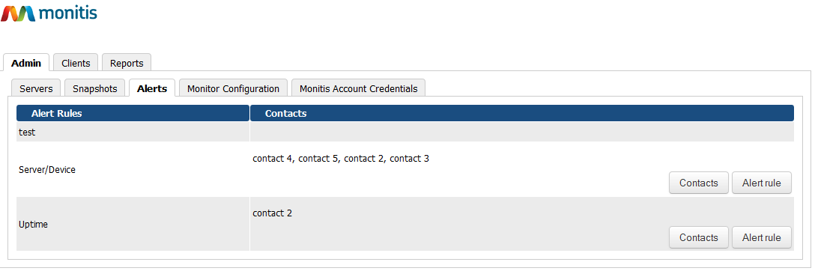

Configure the corresponding settings for Uptime and Server/Device monitors and select the contacts the alerts are to be sent to.

**MONITORING FOR WEB HOSTING CLIENTS**

Monitis addon allows offering monitoring services to hosting clients as a product, product addon or configurable option. Activation and configuration of a service (Product, Addon or Configurable option) as Monitis monitoring service can be done in Client>Product/Services, Client>Addons and Client>Configurable Options tabs.

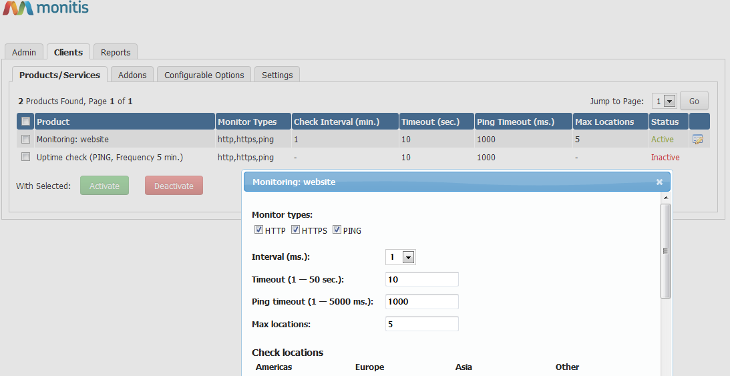

Please note that only Products having type “Other Product/Service” can be activated as Monitoring products. For these products two new custom fields will be created - URL/IP and Monitor Type. Monitors will be created based on data provided in these fields. In case of product addon or configurable option Domain or Dedicated IP fields of the service will be used for creating monitors.

If services activated as Monitis monitoring were used before installation of Monitis addon and there are orders in an active status, you can automatically create monitors for these orders. After creating monitors for existing orders, you will get detailed status reports.

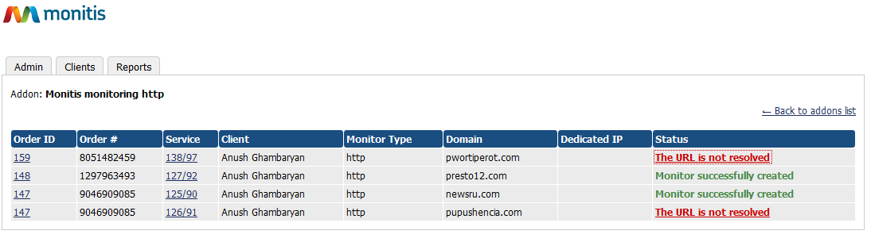

When the clients acquire the Monitis monitoring (either as the WHMCS Product, WHMCS product addon or Configurable Option) and Admin accepts the order then the subaccount is created in the Monitis admin account with no access rights and the client’s contact information is entered as the Contact information of the Monitis Account of the Admin.

In the case of addons and configurable options, you can automatically create monitors for already existing active products/services.

For WHMCS clients subaccounts will be created under your main Monitis account. Client monitors will be added under corresponding subaccounts.

You can as well configure Monitis API actions depending on Product/Addon status changes on Clients>Settings tab.

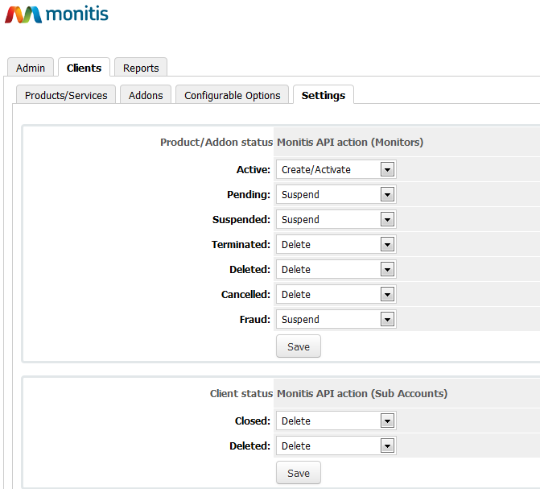

Clients can see and manage their monitors in WHMCS client area. They can change monitoring locations and alert rules.

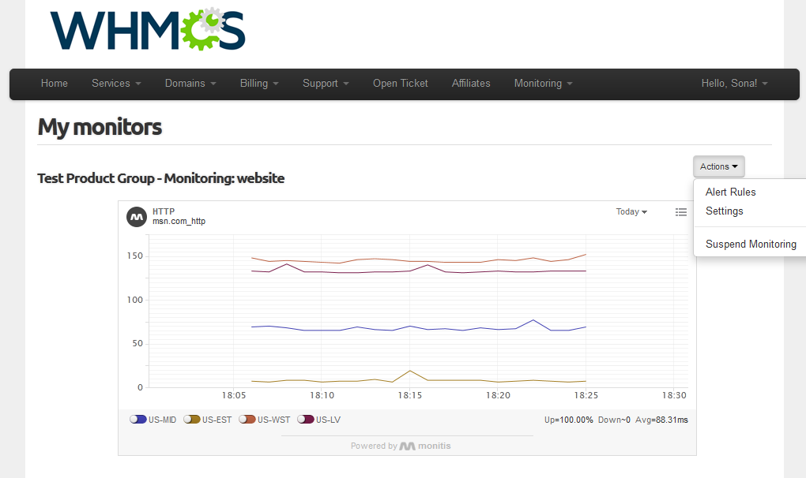

**REPORTS**

Under the Report tabs you can find the Error Log and Inventory Report tabs.

In Error Log you can find information on problems that occur as a result of failed Monitis API calls for creating client monitors. You can see Order/Service information, reasons of the problem, and have a possibility to rerun API command.

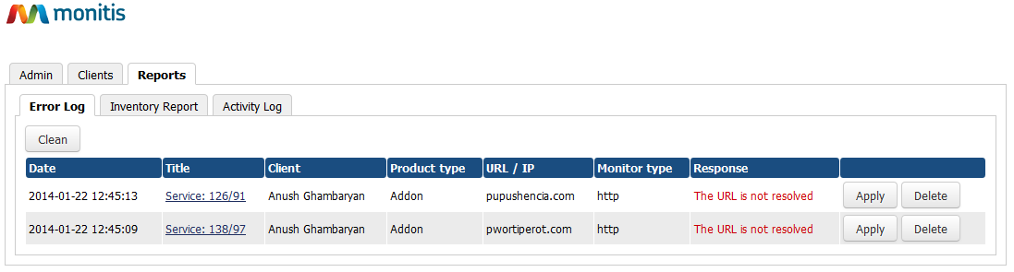

Inventory Report allows comparing client/monitor information in both WHMCS and Monitis accounts.

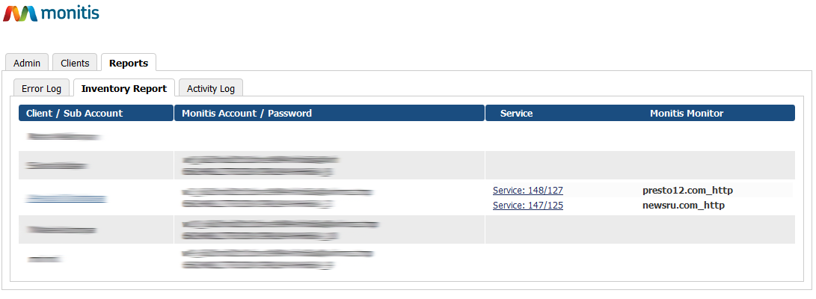

The **Activity Log** tab report contains all Monitis addon activities. It is hidden by default and can be activated in the Monitis addon *config.php* file by changing **MONITIS_LOGGER** parameter value **true**.